**A COMPREHENSIVE ANALYSIS OF FINANCIAL PERFORMANCE:INSIGHTS FROM A LEADING BANKS**

**INTRODUCTION:**

**1.1.OVERVIEW:**

**The project aim is to analyze the bank related data and be able to extract some insights from the data using Business Intelligence tools and to extract the insights from the data and put the data in the form of visualizations.It undertakes a full diagnosis of the profitability and financial soundness of the business.**

**COMPREHENSIVE ANALYSIS:**

**The financial analysis is the process of evaluating**

**business,projects,budgets,and other finance-related transactions to determine their performance and suitability.Typically,financial analysis is used to analyze whether an entity is stable,solvent,liquid or profitable enough to warrant a monetary investment.It is used to evaluate economic trends, set financial policy, build long-term plans for business activity, and identify projects or companies for investment. This is done through the synthesis of financial numbers and data.**

**1.2.Purpose of financial analysis**

**The general purpose of the financial statements is to provide**

**information about the results of operations, financial position, and cash flow of an organization. This information is used by the readers of financial statements to make decisions regarding the allocation of resources. At a more refined level, there is a different purpose associated with each of the financial statements. The**

**income statement informs the reader about the ability of the business to generate a profit.In addition, it reveals the volume of sales, and the nature of the various types of expenses, depending upon how expense information is aggregated. When reviewed over multiple time periods, the income statement can also be used to analyze trades in the results of company operations.**

**RESULT:**

**2.1.DATA MODEL:**

| **Object name** |
| --- |
| **rank** |
| **bank** |
| **country** |
| **Total assets** |

**2.2.ACTIVITY AND SCREENSHOT:**

**MILESTONE_1:**

**PROBLEM DEFINITION AND DESIGN THINKING** 2.2.1. EMPATHY MAP:

**An empathy map is a template that organizes a user's behavior and feelings to create a sense of empathy between the user and your team.**

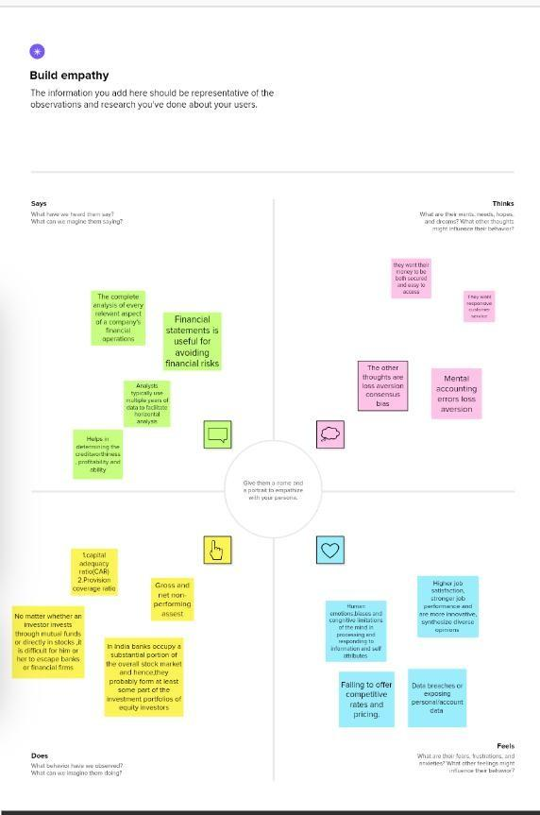

2.2.2 IDEATION AND BRAINSTORMING MAP:

**Ideation is often closely related to practice of brainstorming,a specific technique that is utilized to generate new ideas.A principle difference between ideation and brainstorming is that ideation is commonly more thought of as being an individual pursuit,while brainstorming is almost always a group activity.Ideation is a process of forming ideas from conception to implementation,most often in a business setting.**

**Brainstorming is a group problem solving method that involves the spontaneous contribution of creative ideas and solutions.**

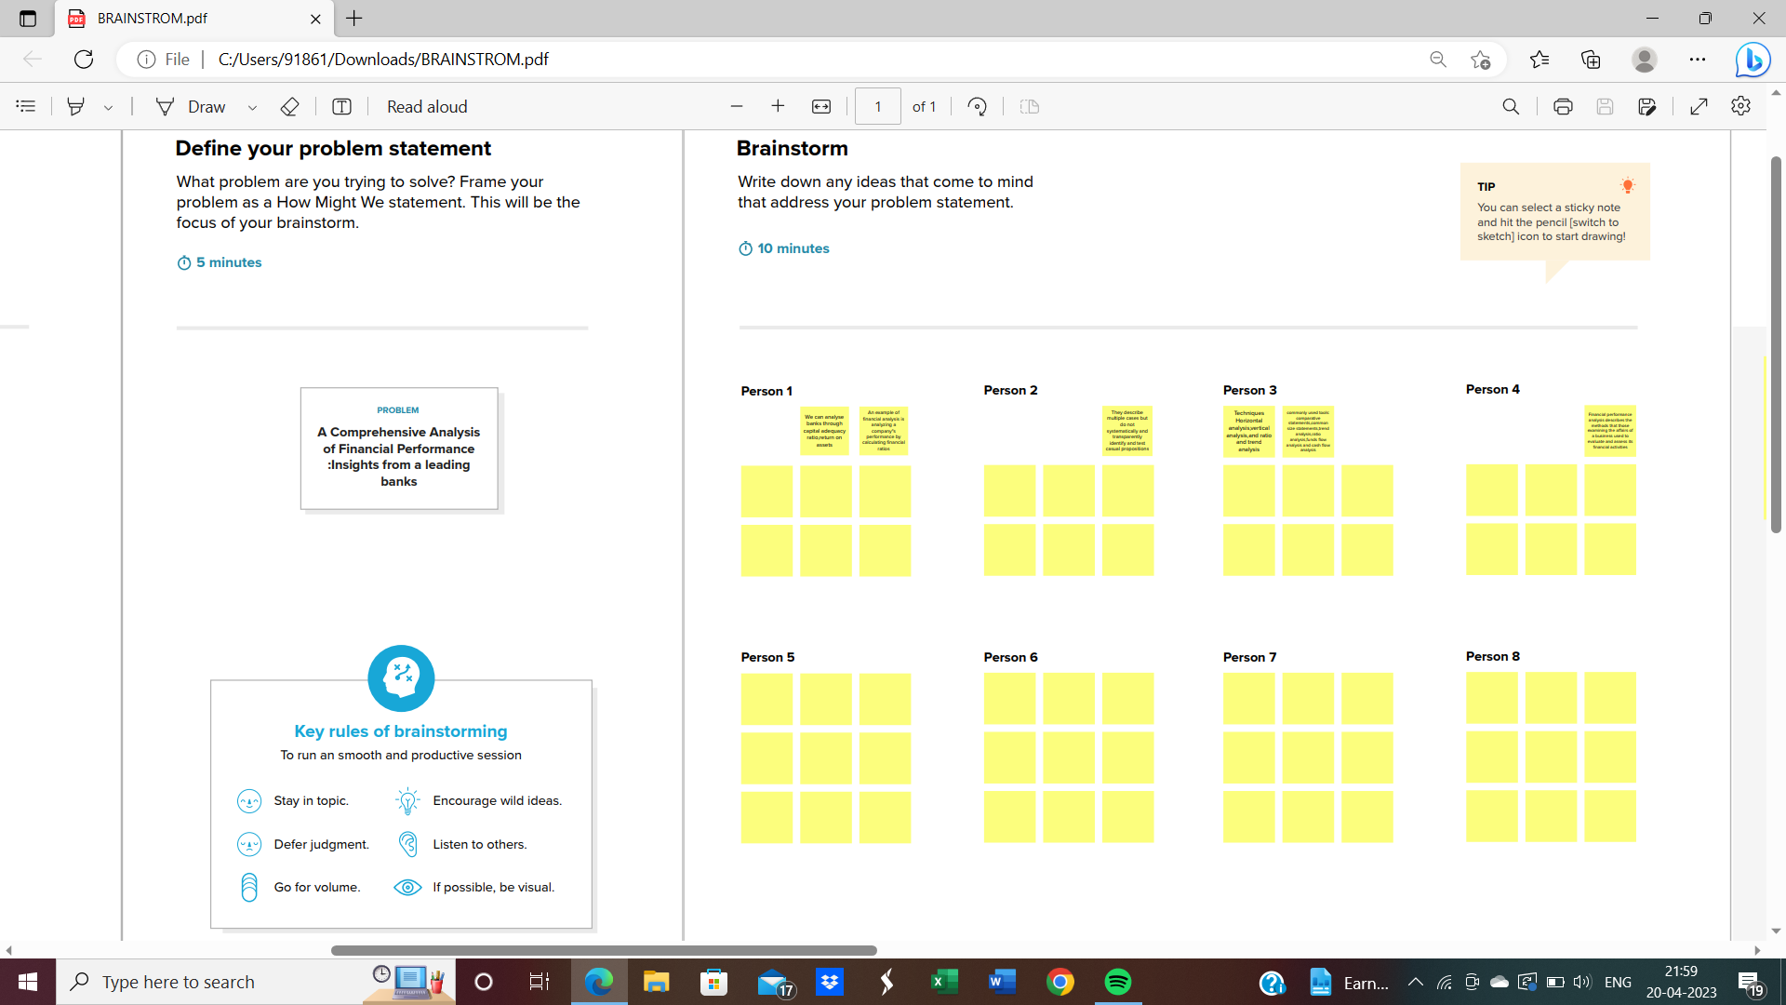

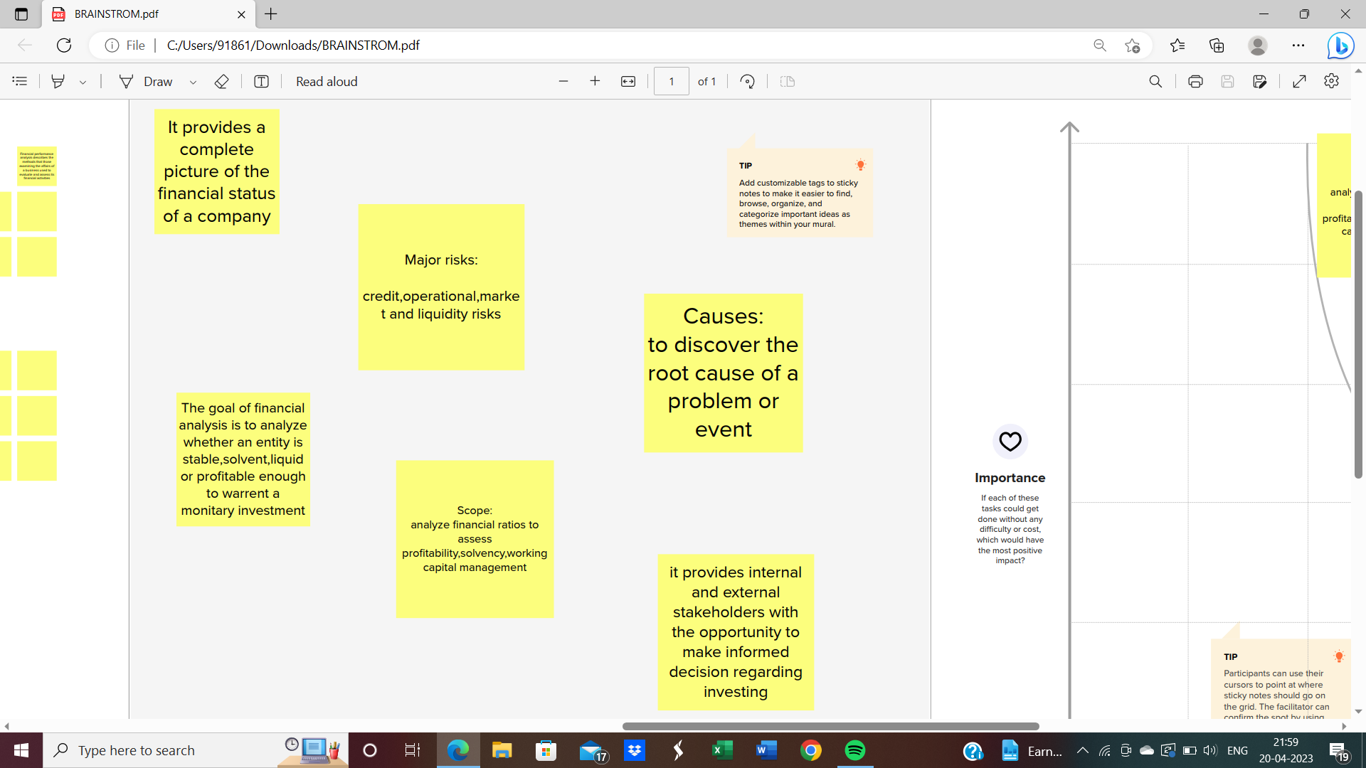

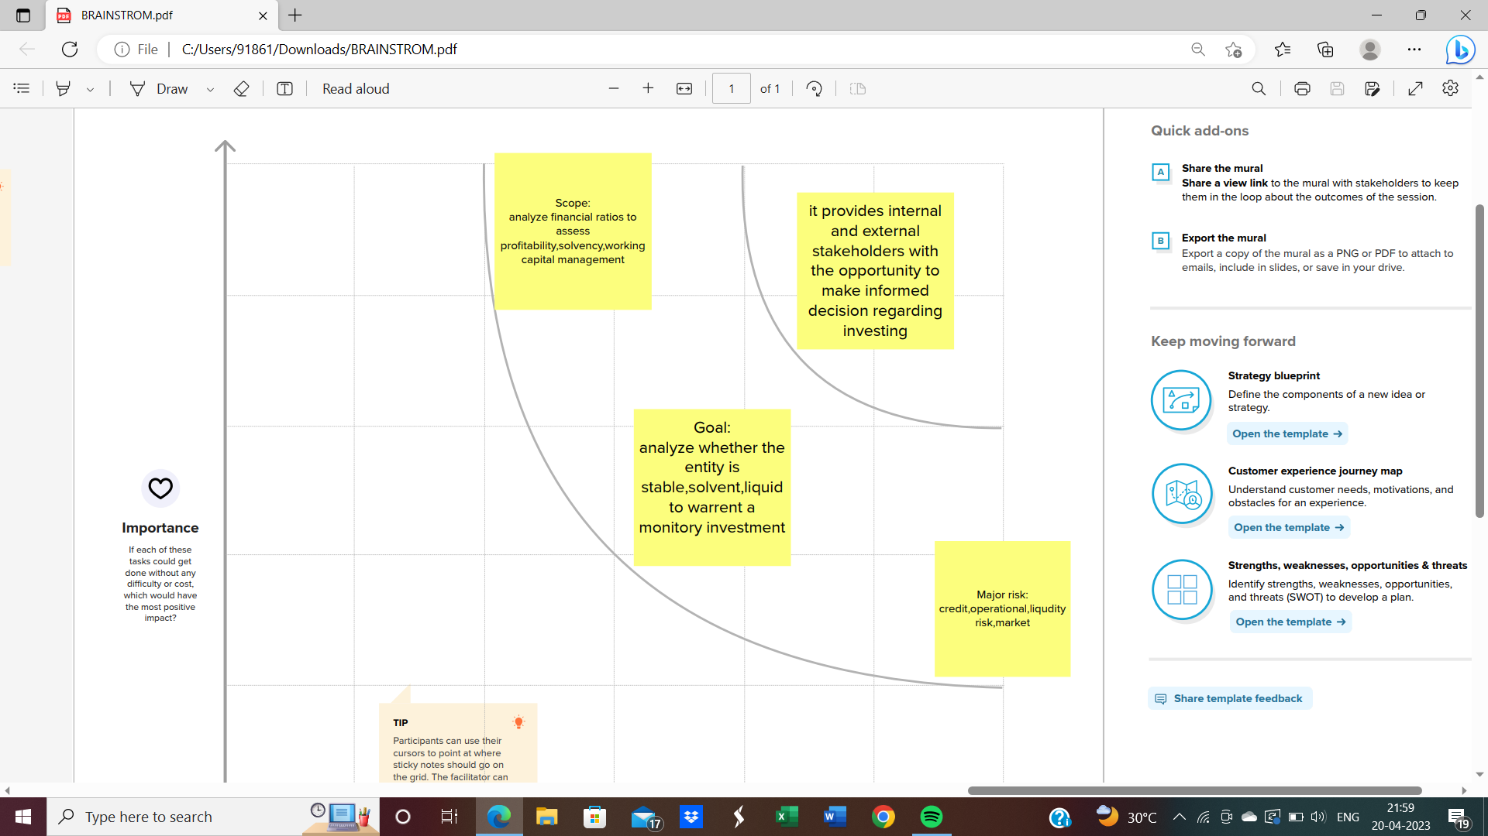

**MILESTONE_2:**

**DATA COLLECTION AND EXTRACTION FROM DATABASE**

**Data collection is the process of gathering and measuring**

**information on variables of interest,in an established systematic fashion that**

**enables one to answer stated research questions ,test hypothesis,evaluate**

**outcomes and generate insights from the data**

**Activity 1:**

**Downloading the dataset**

ACTIVITY 1.1:**Understand the data**

**Data contains all the meta information regarding the columns described in the csv files**

**Column description of the Dataset:**

**1.Bank:Name of the bank**

**2.Country:In which country the bank is operating**

**3.Total Assets:Total assets of the banks**

**4.Rank:Rank of the bank among the world**

**5.Landmass:Under which continent the bank belong to**

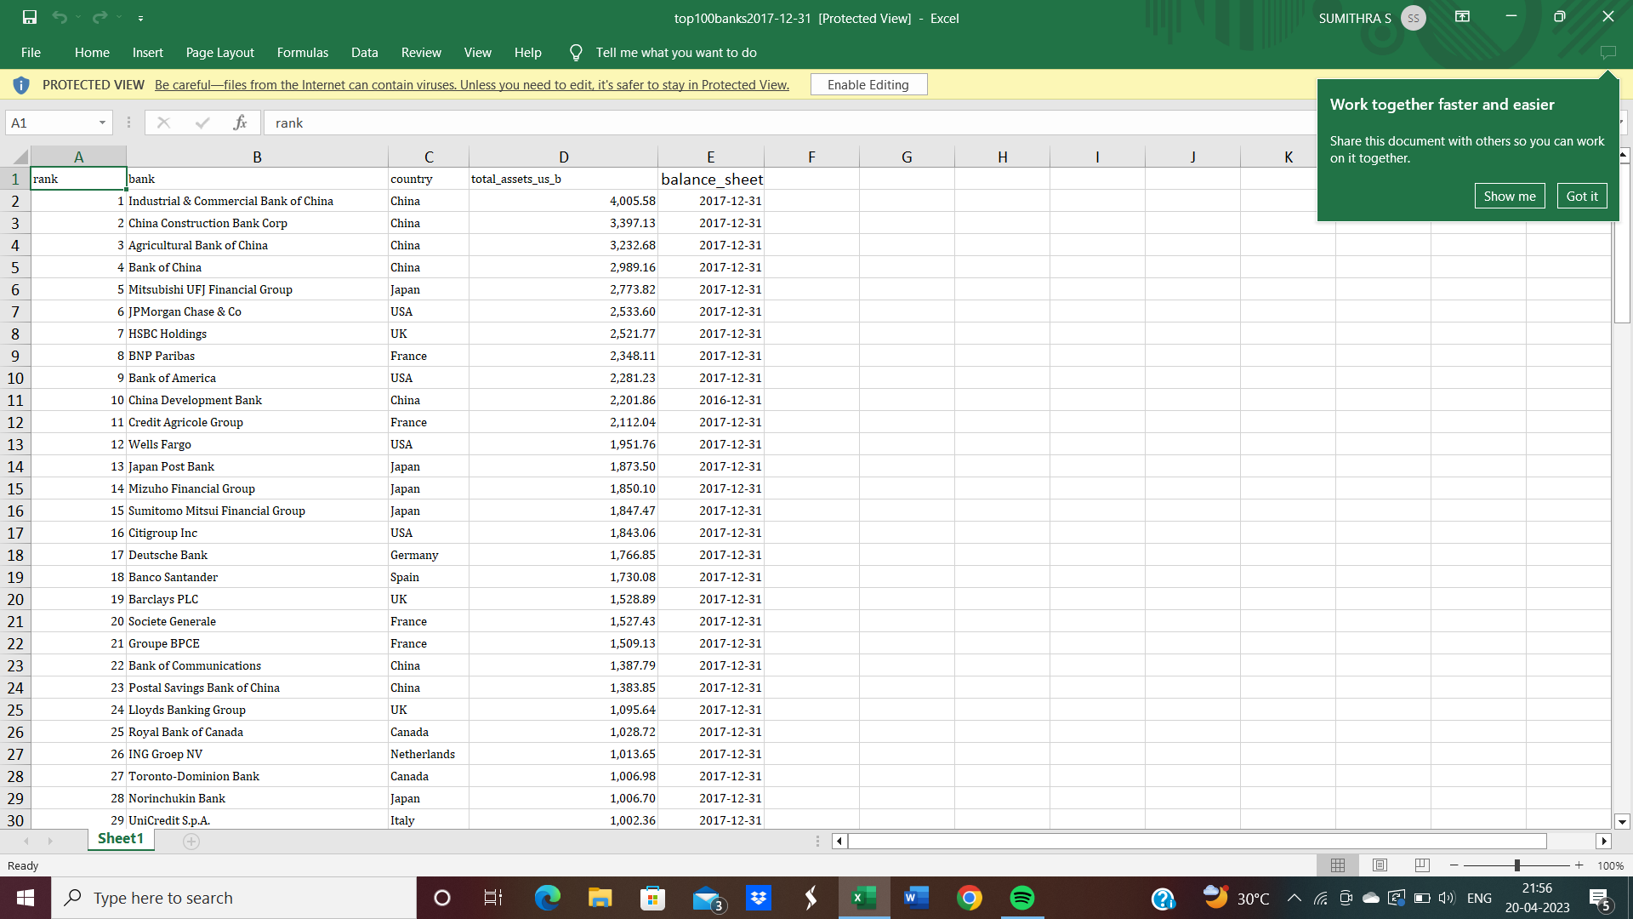

**Activity 2:**

**Storing Data in DB & Perform SQL Operation**



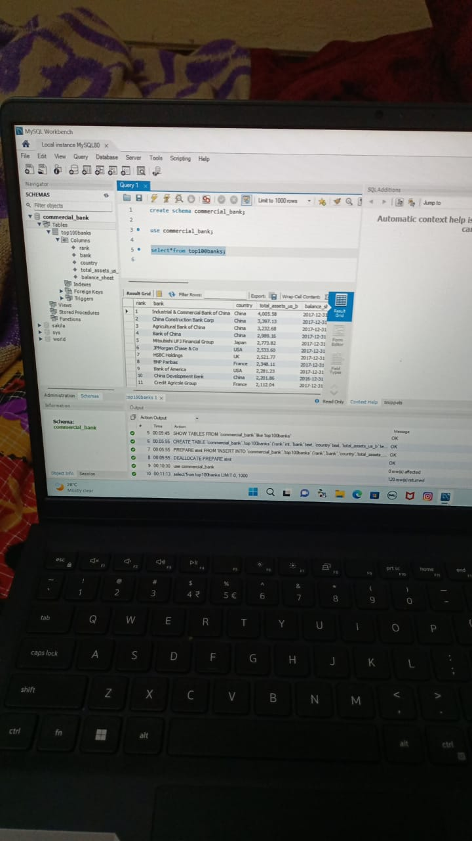

**Activity 3:**

**Connect DB with Tableau**

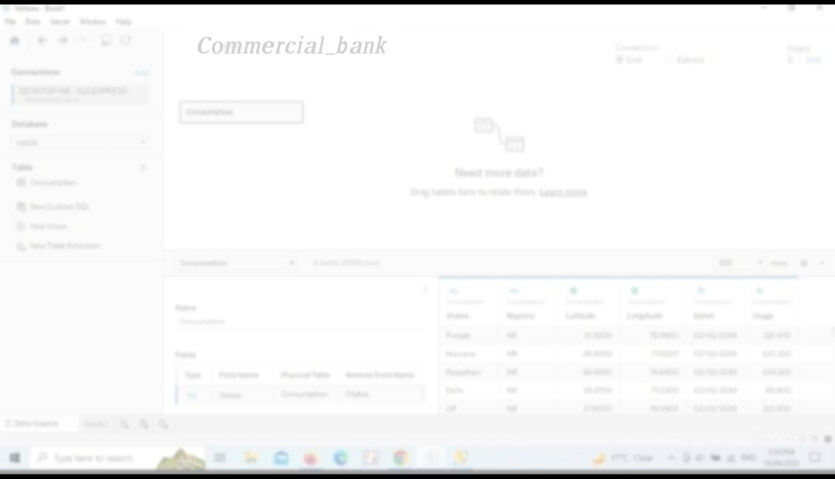

**MILESTONE 3:**

**DATA PREPARATION**

**Activity 1:**

**PREPARE THE DATA FOR VISUALIZATION**

**Preparing the data for visualization involves**

**cleaning the data to remove irrelevant or missing data,transforming the data into a format that can be easily visualized,exploring the data to identify patterns and trends,filtering the data to focus on specific subsets of data,preparing the data visualization software,and ensuring the data is accurate and complete.This process helps to make the data easily understandable and ready for creating visualizations to gain insights into the performance and efficiency.**

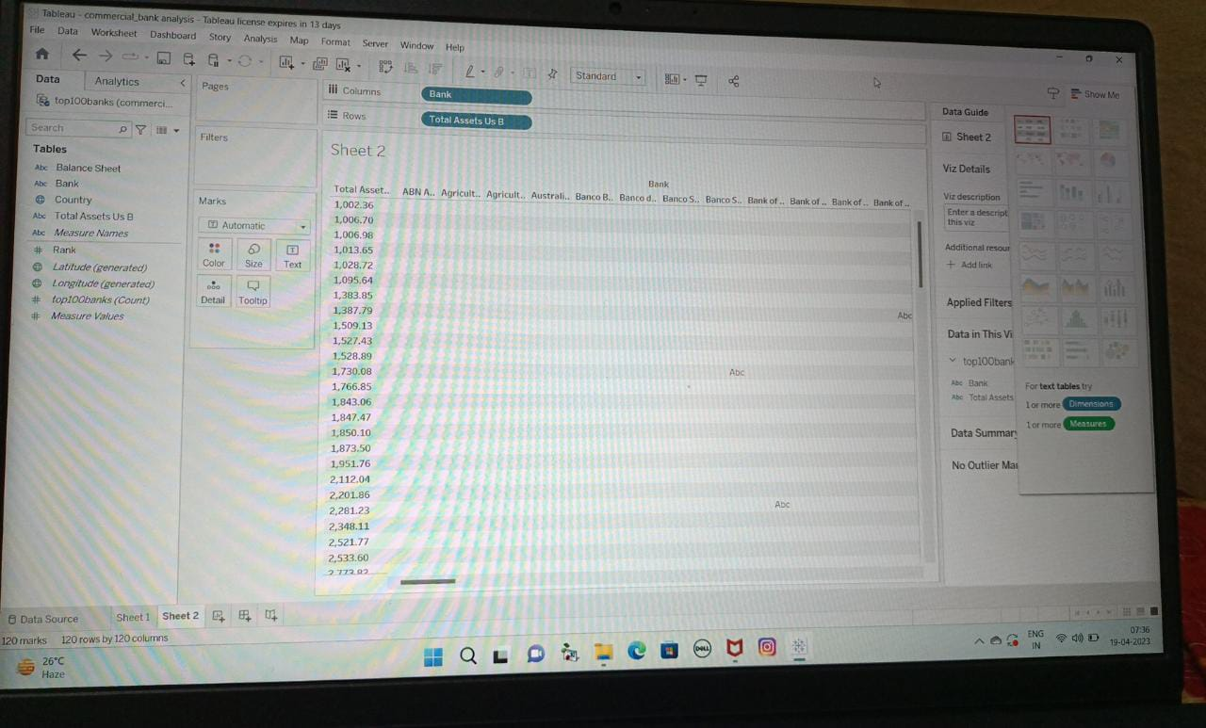

**MILESTONE 4:**

**DATA VISUALIZATION**

**Data visualization is the process of creating graphical representations of data to help people understand and explore the information.The goal of the data visualization is to make complex data sets more accessible,intuitive,and easier to interpret.By using visual elements such as charts,graphs,and maps,data**

**visualizations can help people quickly identify patterns,trends, and outliers in the data.**

**ACTIVITY 1:**

**No of Unique Visualizations**

**The number of unique visualizations that**

**can be created with a given data set.Some common types of visualizations that can be used to analyze the performance and efficiency of banks include bar charts,line charts,heat maps,scatter plots,pie charts,maps,etc.These visualizations can be used to compare performance,track changes overtime,show distribution,and relationships between variables,breakdown of revenue and customer demographics,workload,resource allocation and location of banks.**

**Activity 1.1:**

**Top Banks according rank and assets**

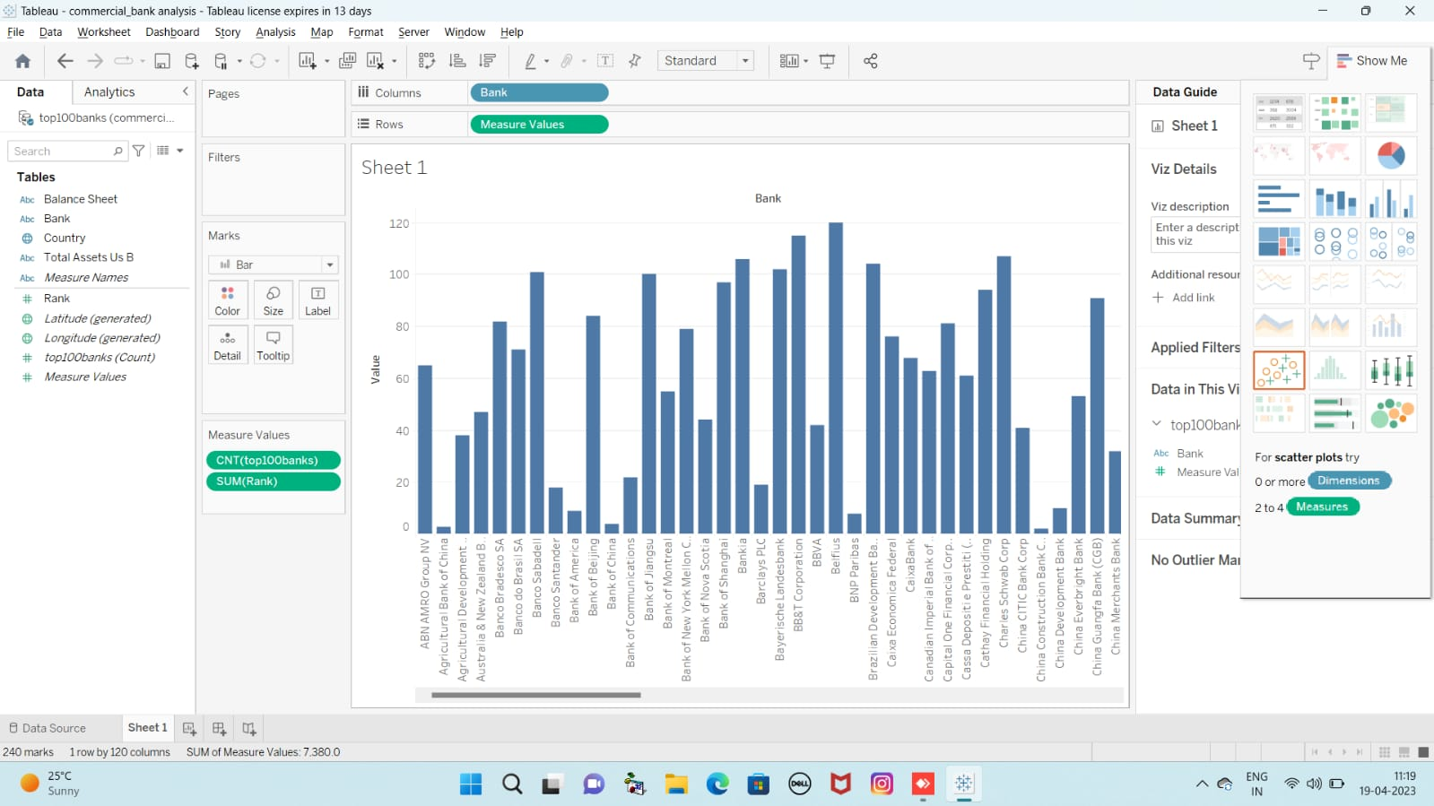

**Activity 1.2:**

**Top banks according to total assets**

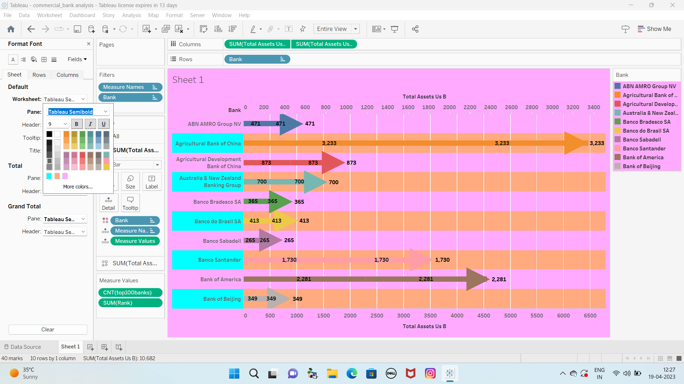

**Activity 1.3:**

**Top banks according to country based on total assets**

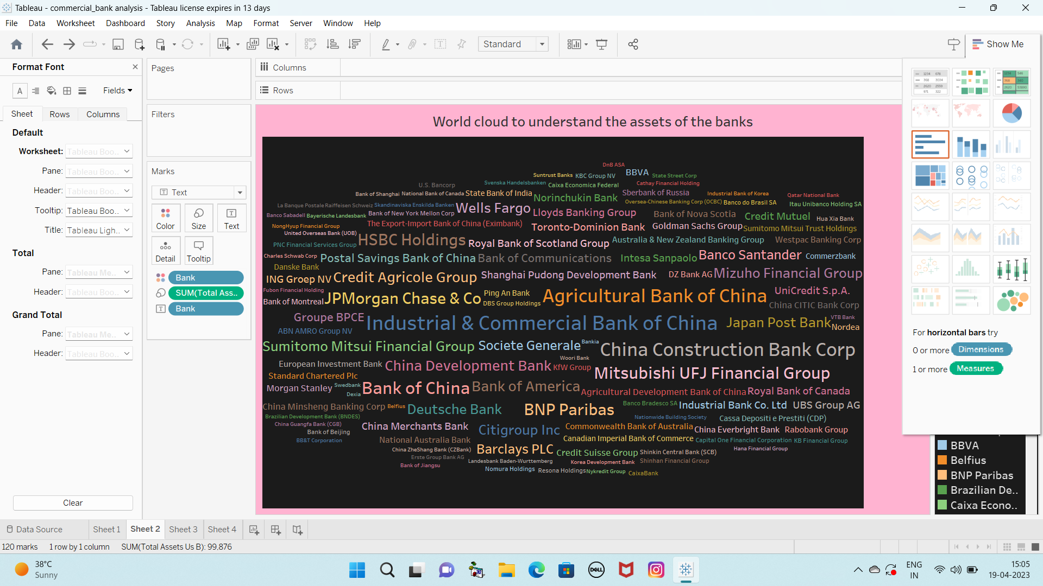

**Activity 1.4:**

**Top 10 Countries with assets proportion**

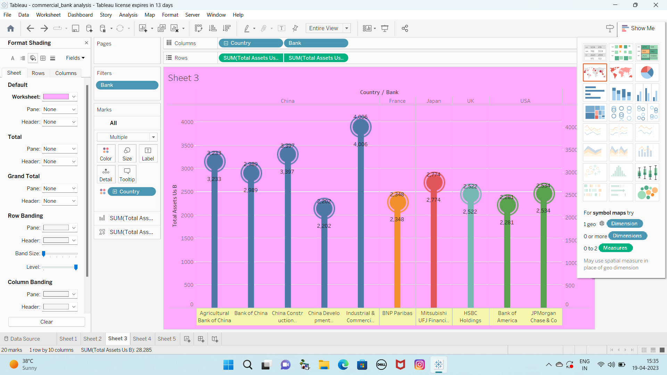

**Activity 1.5:**

**Country with total assets using funnel chat**

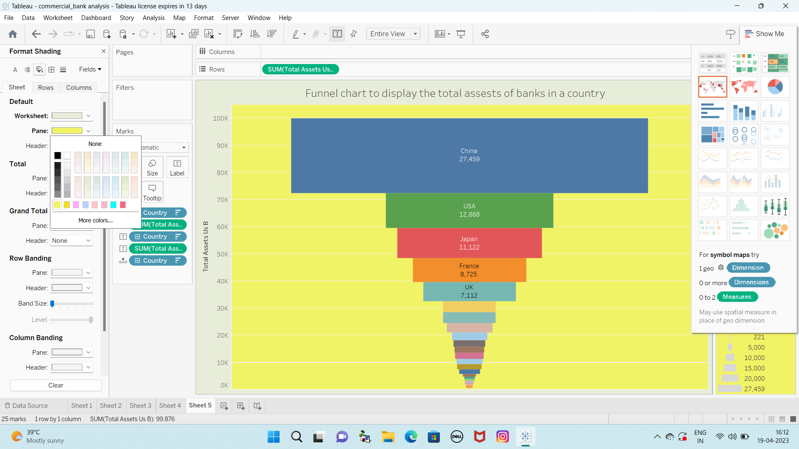

**Activity 1.6:**

**Total assets analysis according**

**to year and quarter**

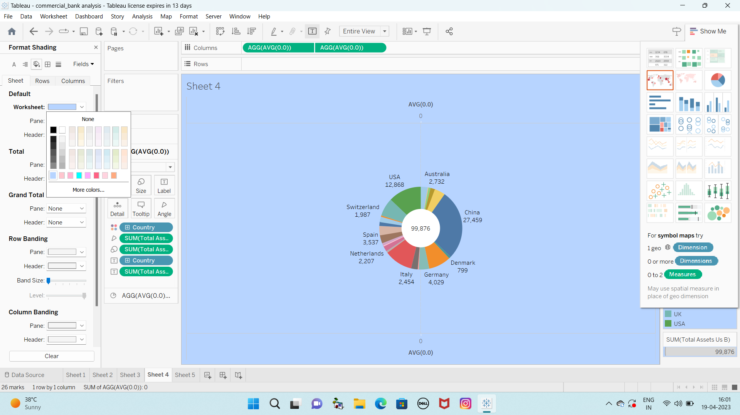

**MILESTONE_5:**

**DASHBOARD**

**A dashboard is a graphical user interface(GUI) that displays information and data in an organized,easy-to-read format.Dashboards are often used to provide real-time monitoring and analysis of data and are typically designed for specific purpose or use case.Dashboards can be used in a variety of settings,such as business.finance,manufacturing,healthcare,and many other industries.They can be used to track key performance indicators(KPIs),monitor performance metrics,and display data in the form of charts,graphs,and tables..**

**Activity 1:**

**Responsive and design of dashboard**

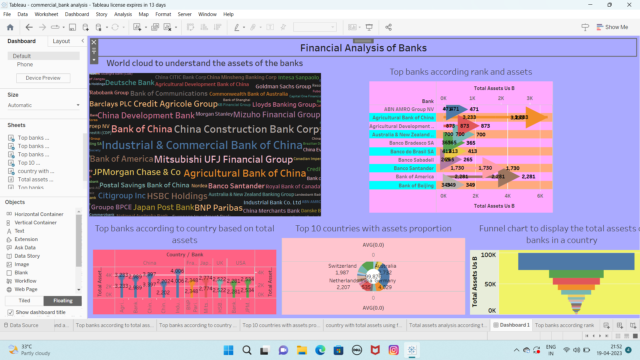

**MILESTONE_6:**

**Story**

**A data story is a way of presenting data and analysis is a narrative format,intending to make the information more engaging and easier to understand.A data story typically includes a clear introduction that sets the stage and explains the context for the data,a body that presents the data and analysis logically and systematically,and a conclusion that summarizes the key findings and highlights their implication.Data stories can be told using a variety of mediums,such as reports,presentations,interactive visualizations,and videos.**

**Activity 1:**

**No of Scenes of Story**

**The number of scenes in a storyboard for a data visualization analysis of the performance of banks will depend on the complexity of the analysis and the specific insights that are trying to be conveyed.A storyboard is a visual representation of the data analysis process and it breaks down the analysis into a series of steps or scenes.**

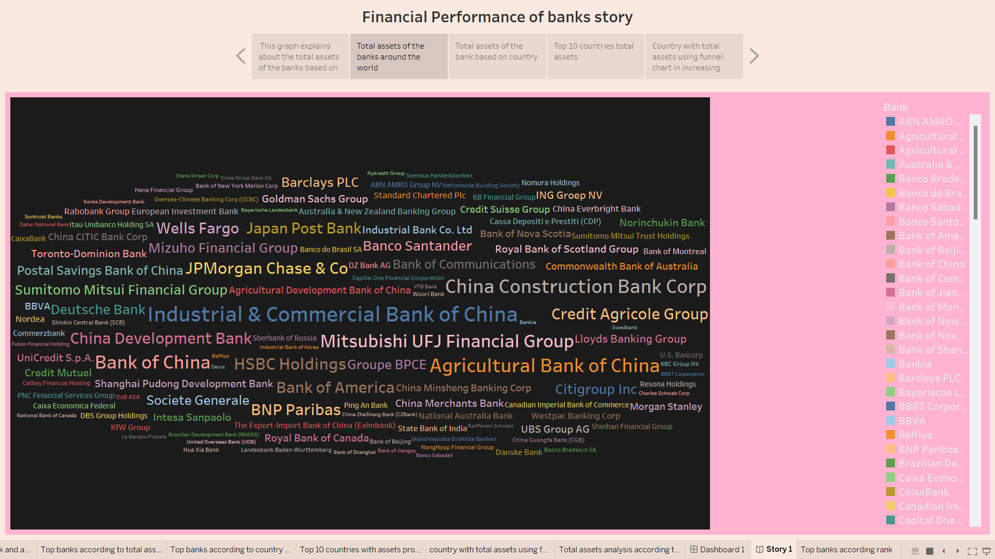

**MILESTONE_7:**

**Performance testing**

**Activity 1:**

**Amount of Data Rendered to DB**

**1.The amount of data that is rendered to a database depends on the size of the dataset and the capacity of the database to store and retrieve data. 2.Open the MySQL Workbench,go to the database then click to expand the tables,select the table and click on (i) button to get the information related to the table such as column count,table rows etc.**

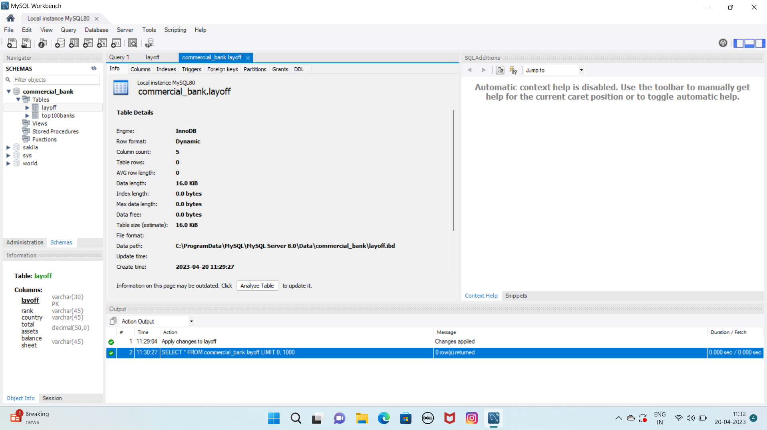

**Activity 2:**

**Utilization of Data Filters**

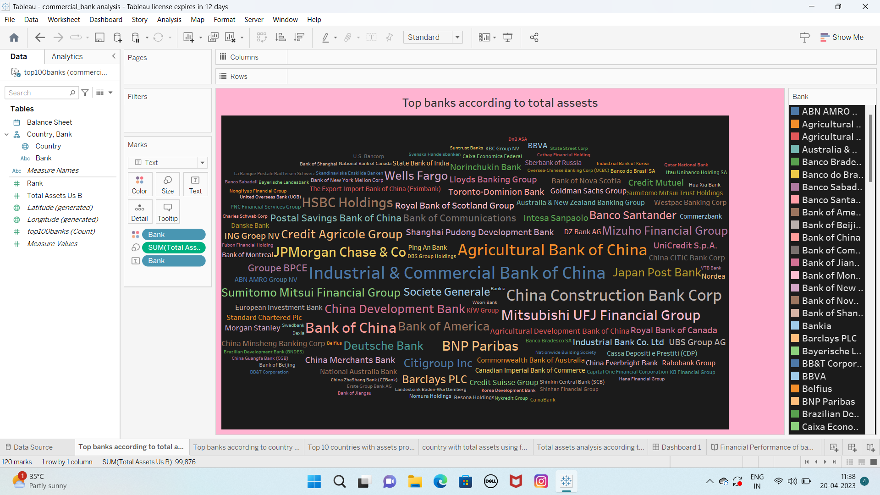

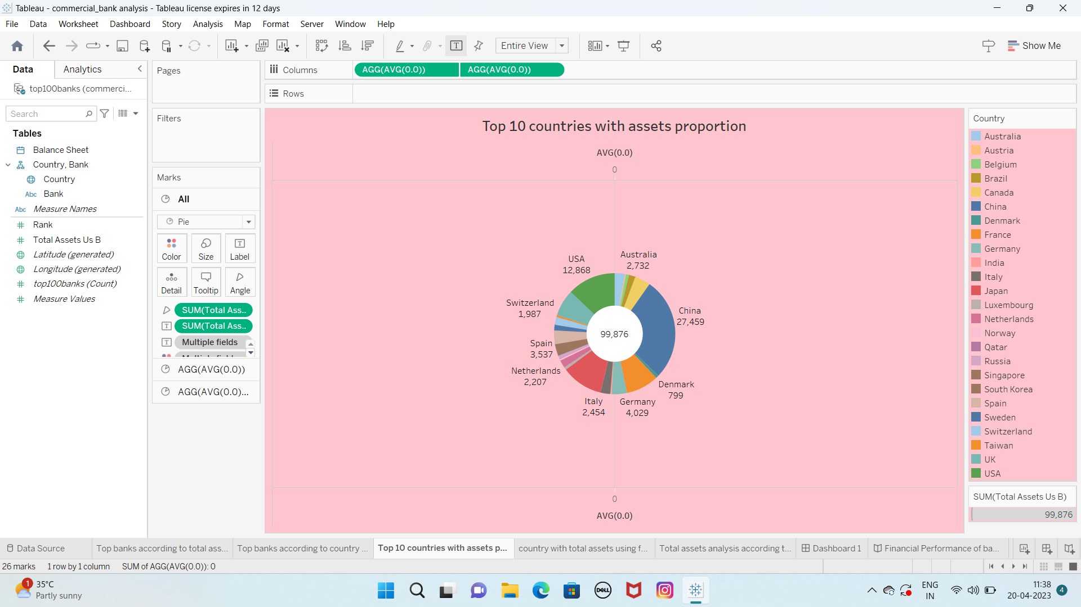

**Activity 3:**

**No of Calculations Fields**

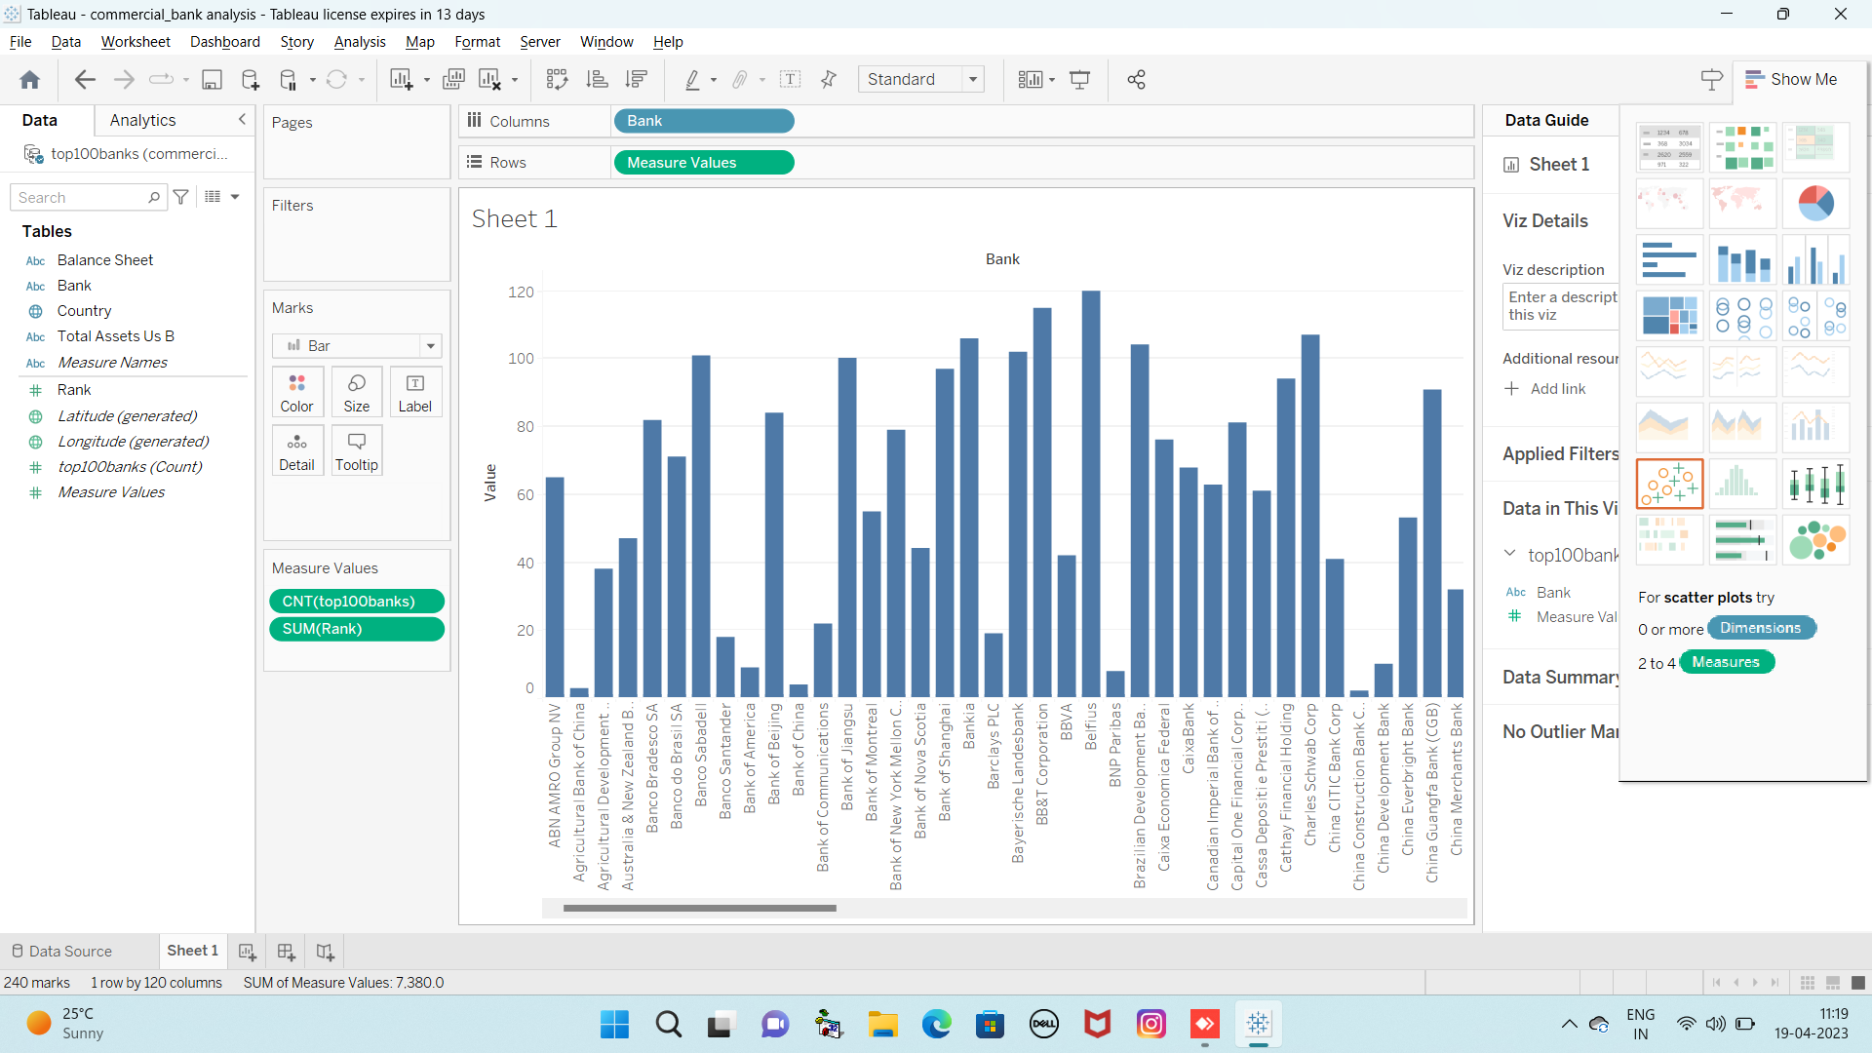

**Activity 4:**

**No of Visualization/Graphs**

**1.Top banks according rank and assets**

**2.Top banks according to total assets**

**3.Top banks according to country based on total assets 4.Top 10 Countries with assets proportion**

**5.Country with total assets using funnel chart in increasing order 6.Total assets analysis according to year and quarter**

**MILESTONE_8:**

**WEB INTEGRATION**

**Publishing helps us to track and monitor key performance metrics and to communicate results and progress.help a publisher stay informed,make better decisions,and communicate their performance to others.**

**Publishing dashboard and reports to tableau public**

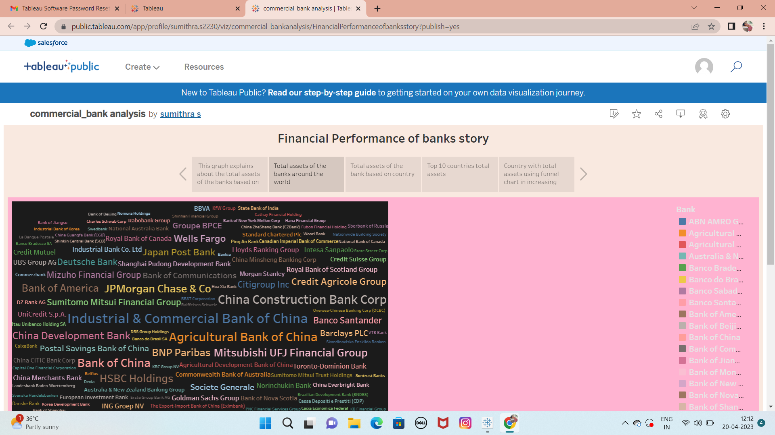

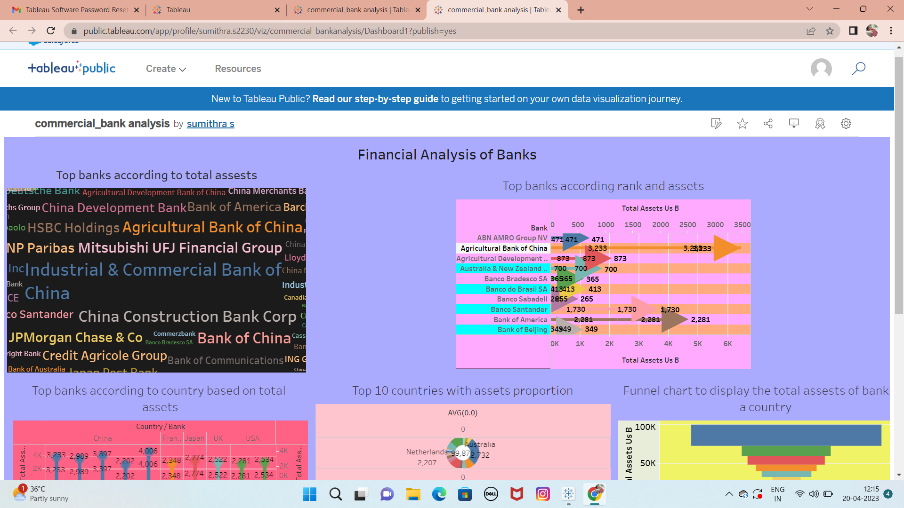

**ACTIVITY 1:**

**Embed Dashboard & Story with**

**Web Bootstrap**

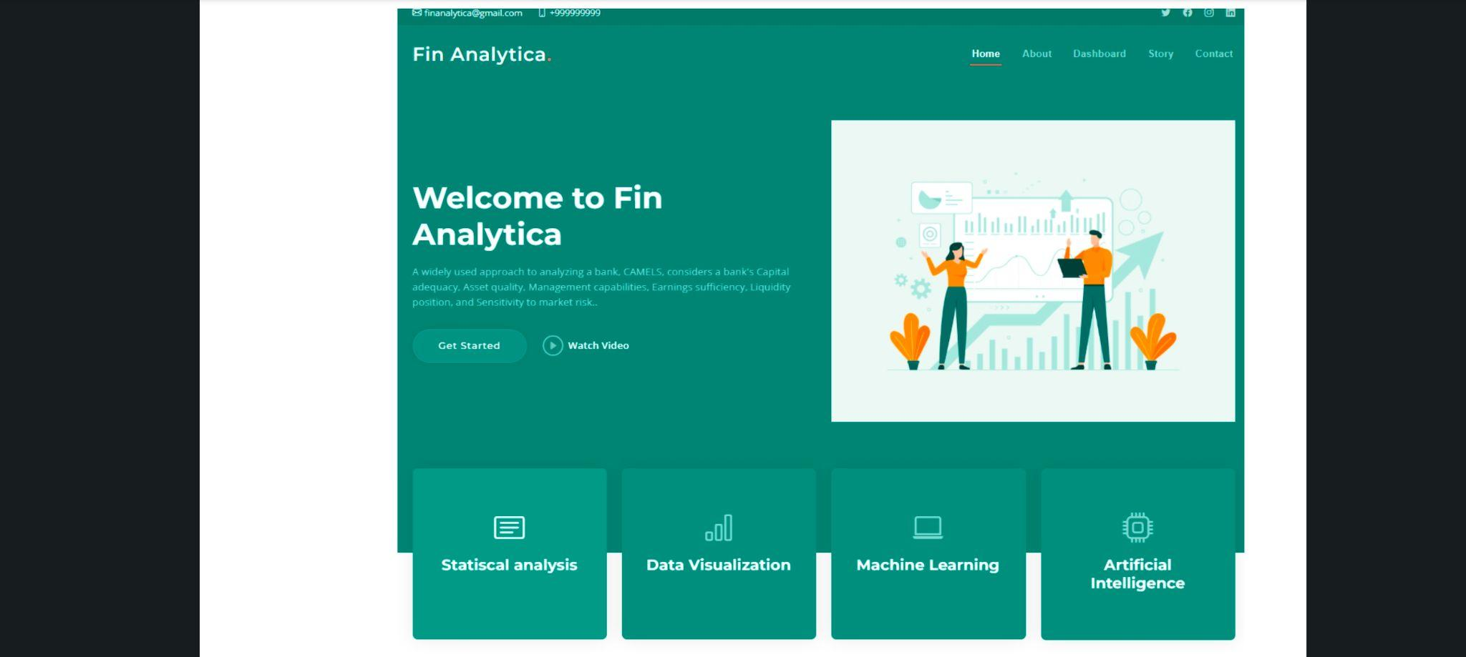



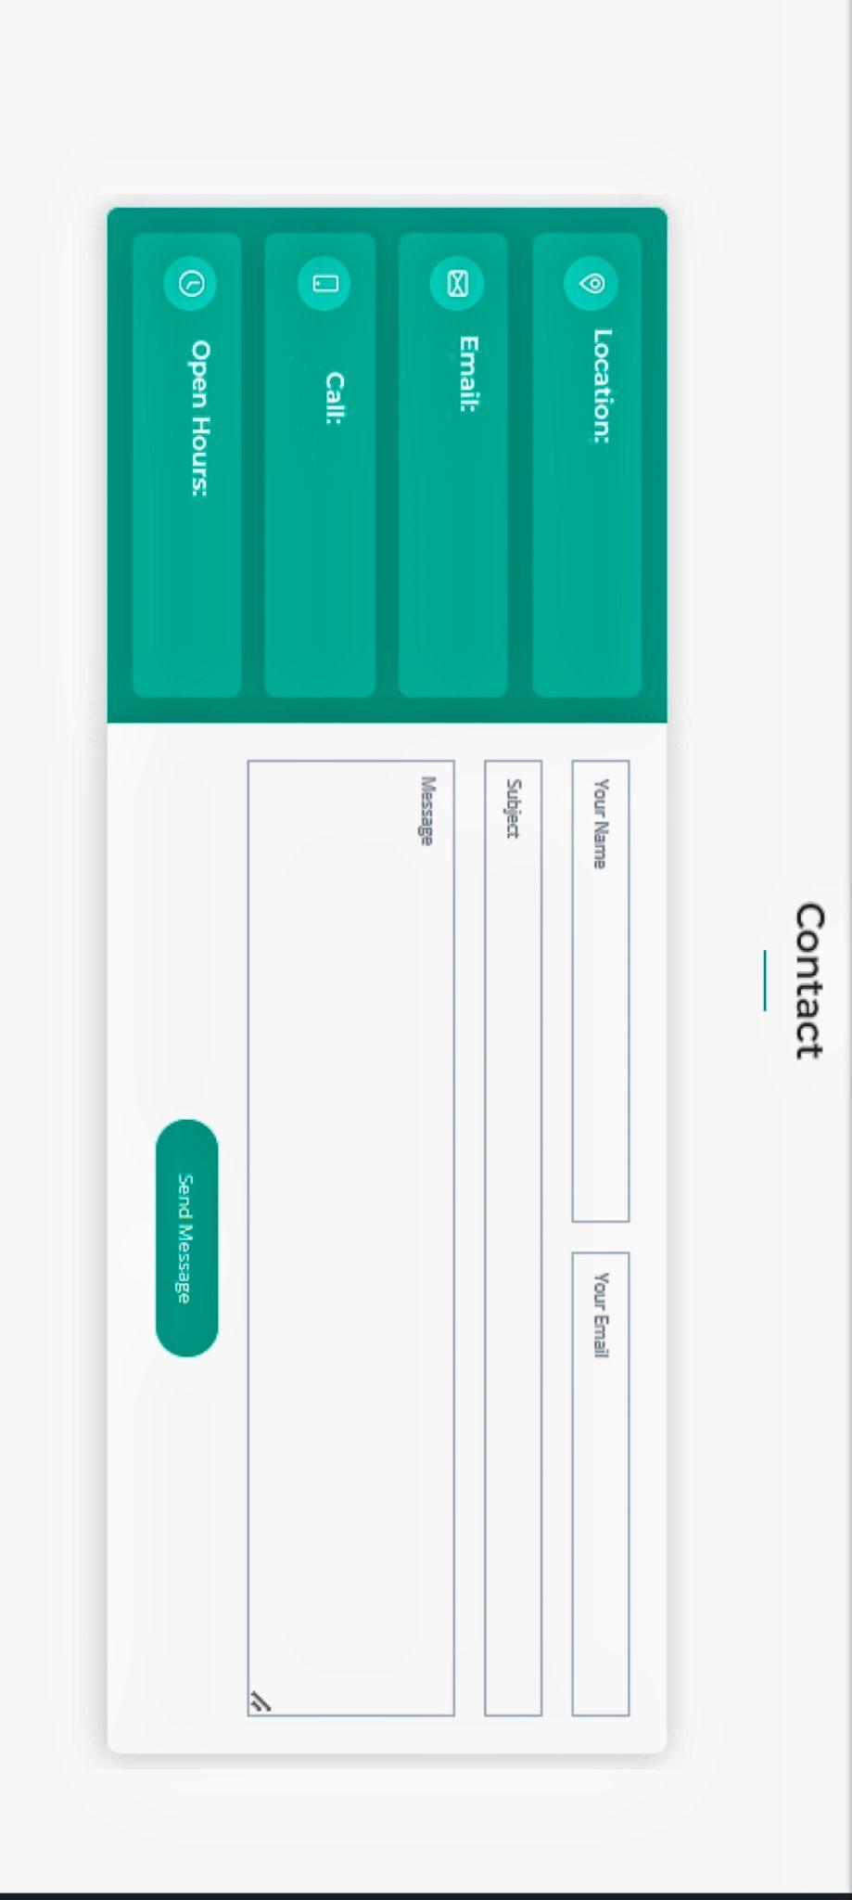

**ADVANTAGES AND DISADVANTAGES:**

**Advantages:**

**1.Real time analysis**

**2.Better debt management**

**3.Optimizing financial performance and compliance**

**4.Cash flow management**

**5.Improved communication and collaboration**

**6.Reducing risk exposure**

**7.Improving supplier relationship management**

**Disadvantages:**

**1.Financial analysis does not consider the price level**

**changes**

**2.Value of intangible assets is ignored**

**3.Financial reports cannot provide any solid information**

**4.It does not help in representing the current position**

**5.Non-monetary facets of business are usually ignored**

**CONCLUSION:**

**Analysis of financial statements is extremely important for every**

**business to grow and increase their revenue.It should not be**

**compromised since it increases the efficiency of business**

**operations . Financial performance analysis describes the**

**methods that those examining the affairs of a business use to**

**evaluate and assess its financial activity.Financial performance**

**refers to the overall financial health of the business.It ensures**

**that the finances of a company are appropriately invested.**

**FUTURE SCOPES:**

**1.Analyze financial ratios to assess profitability,solvency,working**

**capital management,liquidity,and operating effectiveness.**

**2.Banking is facing a future marked by fundamental manufacturing.**

**3.The future of investment banking is expected to be shaped by**

**technological advancements,changes in regulatory environments,**

**and evolving customer needs.**

**4.A subjective measure of how well a firm can use assets from its**

**primary mode of business and generate revenues.**